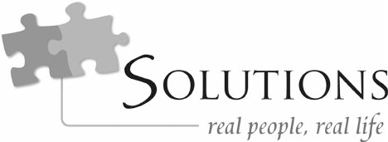

Character Discernment For Dummies, Part 1

Featuring

Dr. John Townsend
Psychologist
Best-selling co-author of Boundaries series, author of Loving People

Character discernment

There will always be toxic people around us: that’s reality
24“The Kingdom of Heaven is like a farmer who planted good seed in his field. 25But that night as the workers slept, his enemy came and planted weeds among the wheat, then slipped
26

A safe person influences you to be the person you were
away.
When the crop began to grow

designed to be
Every relationship moves you toward light or darkness An unsafe person moves you away from the person you were
designed by God to be

This isn’t about blaming people

The unsafe person

You find problems in connection

When you open up, bad things happen You find problems in responsibility
and produce grain, the weeds also
grew. 27The farmer’s workers went to him and said, ‘Sir, the field where you planted that good seed is full of weeds! Where did they come from?’ 28“‘An enemy has done this!’ the
farmer exclaimed. ‘Should we pull out the weeds?’ they asked. 29‘No,’ he replied, ‘you’ll uproot the wheat if you do. 30Let both grow together until the harvest. Then I
will tell the harvesters to sort out the weeds, tie them into bundles, and burn them, and to put the wheat in the
barn.’”
—Matthew 13:24-30

Unsafe people don’t take ownership of their effect on others

We euphemize people: we excuse bad things because there is something we want in them Two aspects that make a person unsafe:
- A life issue: something that is out of growth

- Externalization: they’re not accountable for the issue Blame, rationalization, minimization—not owning
Ownership crosses the bridge from unsafe to safe

Why we choose the wrong people

  - Fear of isolation

  - Defensive hope

  - Filling in blanks

! person plus ! person doesn’t make a whole person

  - Rescue: relating from strength down to weakness

What to do?

  - Connect to the righteous Small groups
Experiences with the good so that the bad feels bad

  - Ask questions

Questions bring things into light

  - Get beyond the sizzle Get to character

CCN Character Discernment for Dummies, Part 1 Page 4

Next week on Solutions: “Character Discernment for Dummies, Part 2”

BOOKS:

Loving People
By Dr. John Townsend www.cloudtownsend.com

Who’s Pushing Your Buttons? By Dr. John Townsend www.cloudtownsend.com

Hiding from Love
By Dr. John Townsend www.cloudtownsend.com
Resources

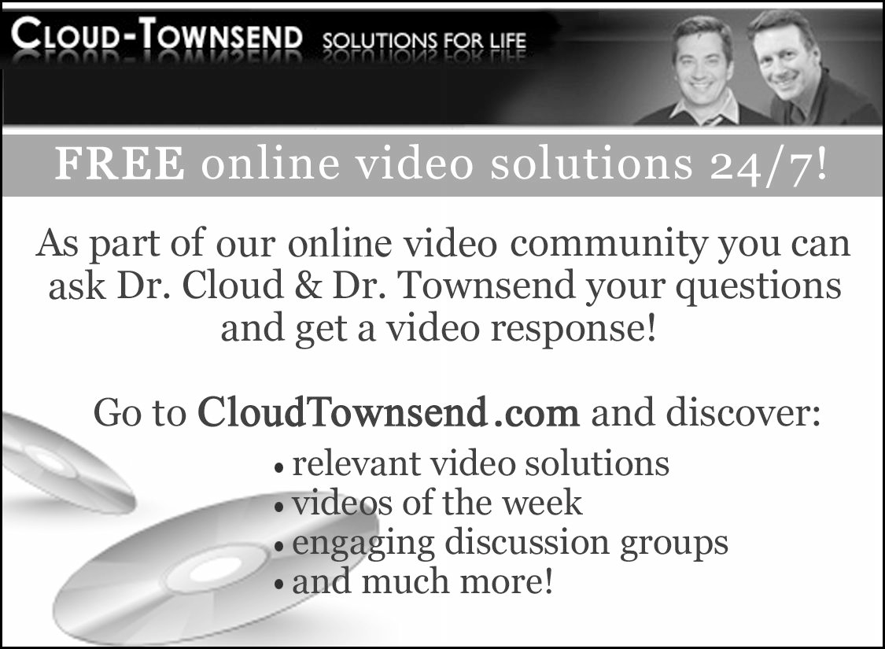

Contact Information

Cloud-Townsend Resources 18092 Sky Park Circle South Suite A
Irvine, California 92614
Phone: 800-676-4673
Web: www.cloudtownsend.com

