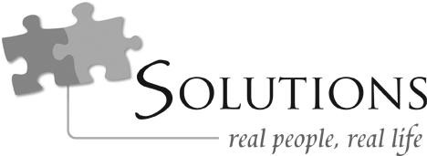

Character Discernment For Dummies, Part 2

Featuring

Dr. John Townsend
Psychologist
Best­selling co­author of Boundaries series and Safe People, author of How People Grow

Relationship heals, and relationship hurts

We need a better people picker

Issues in our lives tend to have people on the other end of them

Guard your heart with all diligence, for from it flow the issues of life.
—Proverbs 4:23

These people don’t just land in our lives without us having a part in it The responsibility for who we choose falls on us
Your people picker needs to have filters

Safe people

You must evaluate people

Don’t have only safe people in your life Jesus built his life in concentric circles
The closer you got, the more he revealed Where your heart is involved, be discerning
Family  familiar

From infancy, patterns develop Two sides to the pattern
Subject/me Object/other
…I will walk with integrity of heart within my house; I will not set before my eyes anything that is base. I hate the work of those who fall away; it shall not cling to me. Perverseness of heart shall be far from me; I will know nothing of evil. One who secretly slanders a neighbor I will destroy. A haughty look and an arrogant heart I will not tolerate. I will look with favor on the faithful in the land, so that they may live with me; whoever walks in the way that is blameless shall minister to me. No one who practices deceit shall remain in my house; no one who utters lies shall continue in my presence. Morning by morning I will destroy all the wicked in the land, cutting off all evildoers from the city of the Lord.
—Psalm 101

In bad situations, people get their attachments before their people picker

What to beware of

  - Apologizers vs. repenters

Does the person say, “I’m sorry,” or does the person change? You’ll see the repenter pursuing health—and you’re not driving it
  - Scene vs. movie There’s a time test
  - Against growth vs. for growth

Those who aren’t coming to the light will resist when you do

  - Religious vs. spiritual

True spirituality: relational and connected

  - No ownership vs. ownership

Without freedom you have no love

But not using freedom responsibly destroys love

  - Defensive, contempt, disconnect, criticism

What to look for

  - Connect

  - Freedom

Do they allow separateness? Is your “no” respected?
  - Real: both good and bad

  - Adult, equal

Not looking for parents, not looking to parent

Love

Responsibility Freedom

CTR Character Discernment for Dummies, Part 2 Page 4

Next week on Solutions: “Dream Lover”

BOOKS:

Loving People
By Dr. John Townsend www.cloudtownsend.com

Who’s Pushing Your Buttons? By Dr. John Townsend www.cloudtownsend.com

Hiding from Love
By Dr. John Townsend www.cloudtownsend.com
Resources

Contact Information

Cloud­Townsend Resources 18092 Sky Park Circle South Suite A
Irvine, California 92614
Phone: 800­676­4673
Web: www.cloudtownsend.com

